Creating a community book group in your setting

What is a community book group?
Community book groups are run in community settings such as youth centres, wellbeing groups and libraries.
Book groups are beneficial to the community and to an organisation for a number of reasons. They provide an additional inexpensive and popular activity for your setting; they create a space to read for pleasure which is beneficial for wellbeing; and help to connect isolated members of the community.
Have a look at some books one of our current book groups have been reading:
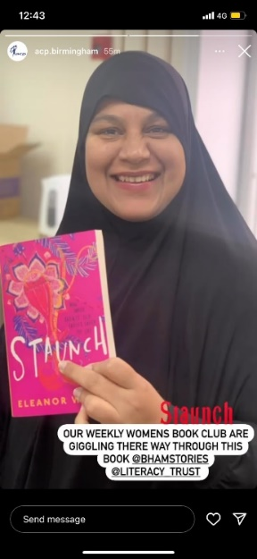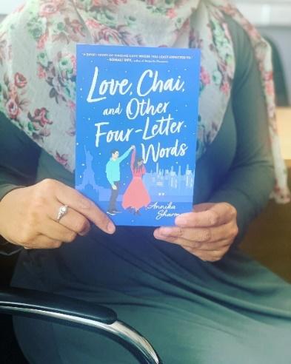

How do community book groups work?
Community book groups are set up and facilitated by a member of staff or a volunteer from the organisation, rather than developed by beneficiaries, as this helps to ensure that someone is in a leadership role from the start.
Book groups are usually hosted once a week at the same time and participants have an hour or so discussion of a chapter of the chosen book that they read at home. The facilitators will have needed to have read the book themselves or have a question for the group ready which is relevant to the book/chapter to kick off the discussion. (More information about topics for discussion are below).

How do I set one up?
If you want to set up your own book group you need to sign up as a literacy champion (if you are not one already!) and once you have completed your training you just need to email Laura: laura.michelangeli@literacytrust.org.uk and express your interest.
Remember to consider these questions:
- Where and when will I host my book group- is there a good time for everybody e.g.: after work?
- Who will be the staff member/volunteer in charge of facilitating the book group?
- Who will be the people that will use the book group – is it for a specific group only or is it advertised publicly?
- Should the book group have a theme to make it relevant for its audience e.g.: books written by women, books with black main characters etc.?
- How will I make the book group a welcoming place to be – providing teas and coffee, time at the start to catch up on each other’s lives, etc.?

Recruiting for your book group
Recruitment can be done in two ways:
- Having a group of people, you are interested in engaging and referring people to the group.
  - For one of our book groups this was women who were isolated and had already been using the centre but weren’t previously connected to each other
  - For another book group this was children that were already attending a homework club
- Publicly advertising the group
  - This could be using posters and leaflets in the centre with a time/date of the first session or a way to express interest.

Where do I get the books?
We provide books as part of the Literacy Champion programme, although we ask that you have people signed up to the group before you request books, so we can purchase the correct amount.
We can support you with whatever age range and genre of books works best from our current stock of books. In some special cases we are able to provide specific books as long as they are on our ordering system, and we are able to secure funding for your group ie: if it is in our target ward.
Books will need to be picked up from our storage unit: Safestore Self Storage, 50 Highgate Middleway, B12 0DG. So, you’ll need to arrange a time to meet Laura there.

How do I run a book club?
We have attempted to create a framework for a book group below to help make the process easier, but remember you know your communities best and this framework is just a suggestion for how to proceed!

Prior to first meeting
- Have answered all the questions in the “How do I set a book group up?” section.
- Decided on the first book and received your copies from Laura.

Meeting structure
- Introduction and chat
- Book discussion
- Debrief, agree on what will be read before the next meeting.
  - If you are running a book club for children, consider running a game either at the start or end of the meeting – ideas for games are available from Laura.

Discussion ideas
- ‘Review’ questions: ‘Did you enjoy the book/chapter?’ or ‘Would you recommend it to someone else?’
- Questions on the author: ‘What did you think of their writing style?’ or ‘What were their strengths as an author?’
- ‘Feeling’ questions: ‘Did the book make you feel sad at any stage? Why?’ or ‘What emotions did you feel in this part of the story?’
- ‘What if’ style questions: ‘What if character A had never met character B?’ or ‘What if the book had been set in France instead of in America?’ etc.
- ‘Debate’ questions: ‘Should Character A have married Character B?’ or ‘Was it right that Character C left the country?’
- ‘Predictive’ questions: ‘Were there any plot details you thought would happen?’ or ‘Were there any twists that shocked you?’
- Questions on the book’s title and cover: ‘Do you think the cover matches the plot?’ or ‘Now we know the story, why do you think this title was chosen?’
- Reflective questions: ‘What has the book taught us about our own lives?’ or ‘Is there a strong message to the story?’
- You can also find a good list of specific questions by searching: “‘title’ + book club questions” using a search engine.

After the meeting
- Facilitator to have read the next chapter.
- Remind attendees of the next session e.g.: via a WhatsApp group.

If you are interested in setting up a community book group, please email Laura laura.michelangeli@literacytrust.org.uk. Thank you!

