Inspiration 7

Barge speed or something faster?
I play lots of creative games when I write. In my first novel Artichoke Hearts (Macmillian Children’s Books) the writing tutor Pat Print gets her creative writing group to answer lots of questions to inspire them to write well rounded characters. Random questions like… If your character was a bird what bird would they be? That scene is a workshop I do for myself! One of the questions I ask about my characters is – If this character had a favourite mode of transport by water what would it be? A row boat, an ocean liner, water skis, kite surfing etc.
In When Secrets Set Sail Usha discovers that her mode of transport is a barge!
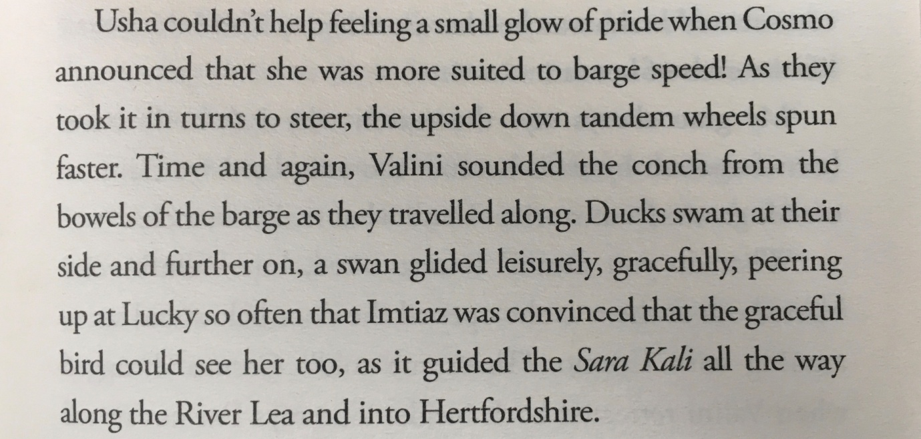
Page 235 When Secrets Set Sail ( Hachette Children’s Books)

Water Characters!
Write a scene in which your character discovers their perfect form of travel on or under water. Barge speed is not for everyone! In the River Whale Imtiaz discovers that she is much more suited to river diving!

