Inspiration 6

Water and Danger
‘Sea is quiet in first hours. Moon is like a silver coin. Sea and sky are no difference – where one ends, other begins. Only land is missing. Boy wishes on light of universe to take him to safe place, Inshallah’ (Amir’s voice from the story Amir and George by Sita Brahmachari)
Watch this book trailer from an animation that myself and Onjali Q Rauf (author of ‘Boy at the Back of the Class’) have contributed story development to along with an international team. We are both writers and we also both work as activists drawing attention to the plight of refugee children and the dangers they face journeying unaccompanied in our world today.
Watch this trailer from the animation ‘Footsteps On The Wind’ .
Draw around your own foot. Using a mixture of drawing and free writing try to write what you see and feel as you watch the animation.
Spend some time in your class talking about how the news of refugee children travelling at sea makes you feel. Decide together what actions you can take:
https://www.youtube.com/watch?v=Bm1JIEr819c
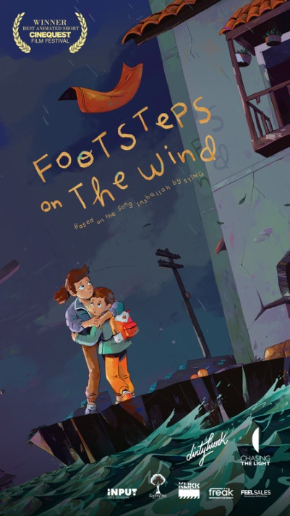
To find out more about how you and your school can be involved in this international humanitarian project visit: https://www.footstepsonthewind.com/
https://www.un.org/en/exhibits/exhibit/voices-wind/home

