Inspiration 5

Watching a sunset or sunrise over the water … feelings of awe and wonder
In a lot of my stories there are moments when characters are in awe of nature.
Read this passage from ‘Jasmine Skies.’ Mira is sitting on the banks of the River Hooghly, a tributary of the Ganges. Read it only once then draw a picture from memory. Collect together the vivid descriptions and adjectives that build the picture in your mind. Now write a description or poem of watching a sunrise or sunset over water yourself. Think about the feelings it creates in you or your character as Mira does.

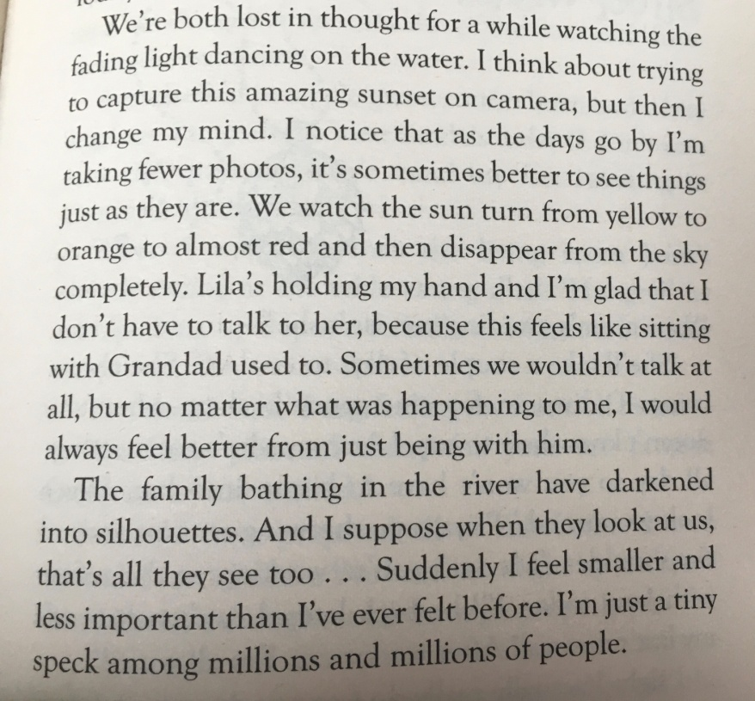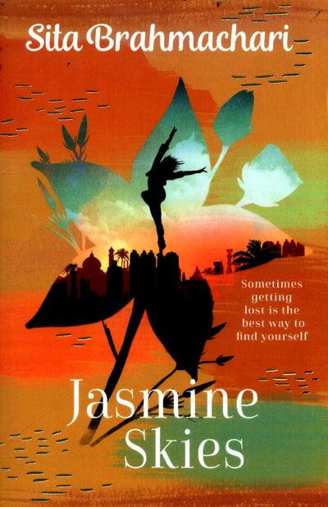

Tip! You might have a photo that can inspire you.

