Inspiration 3

Water Spirits
Where there are ghosts or spirits water is never far away. In When Secrets Set Sail there are lots of ghosts. The first to appear to Usha is Kali Ma. She rises out of the water on the back of a whale! The second is ‘Lucky’ and she appears to Imtiaz while she’s swimming in the Lido. When Imtiaz is swimming she goes to another place in her mind and body.
Brainstorm words or phrases about how you feel when swimming or near water. It might depend on the mood and type of water e.g calm or raging sea, still lake or waterfall?
Read the passage below.
Picture yourself by water where you meet a spirit or a ghost.
Write this meeting. Create as much atmosphere as you can. 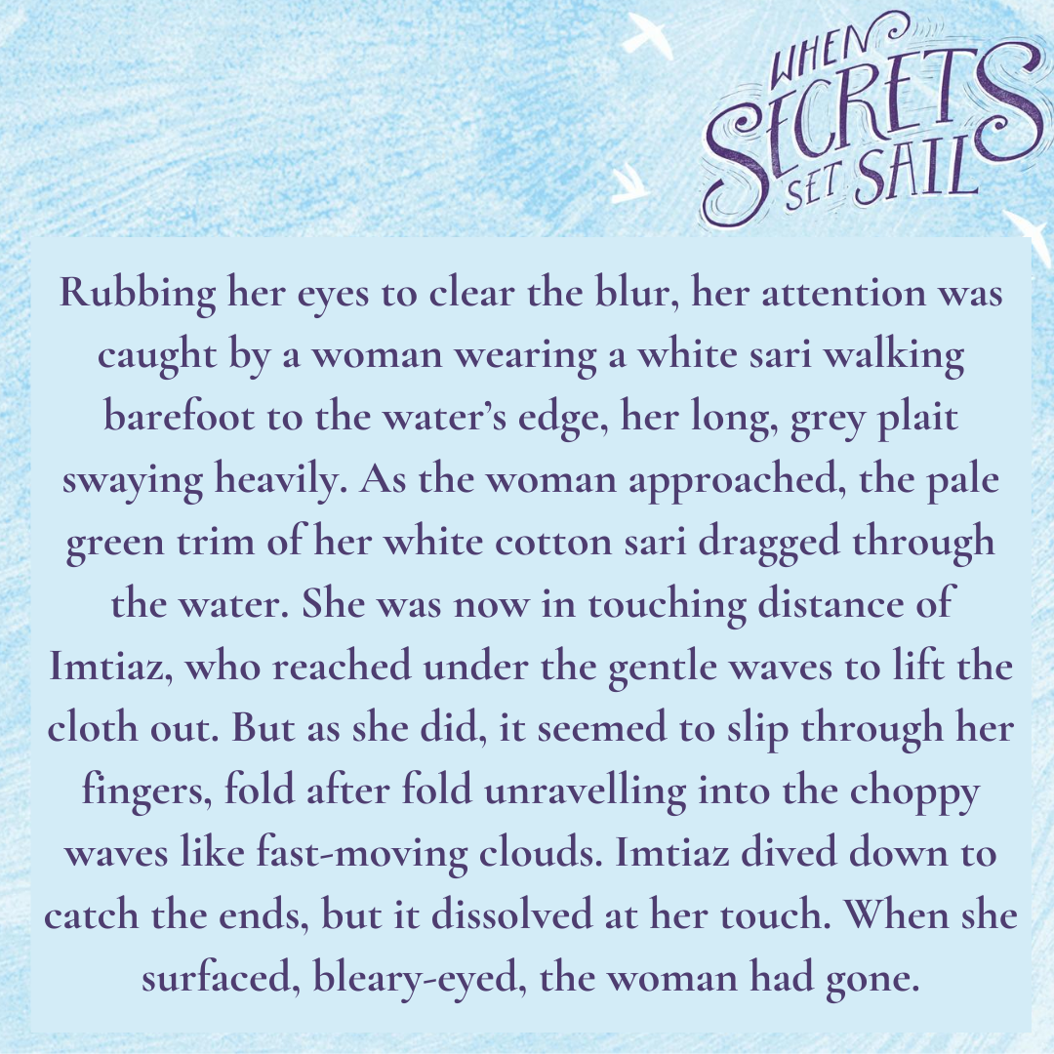
Happy ghost story writing!

