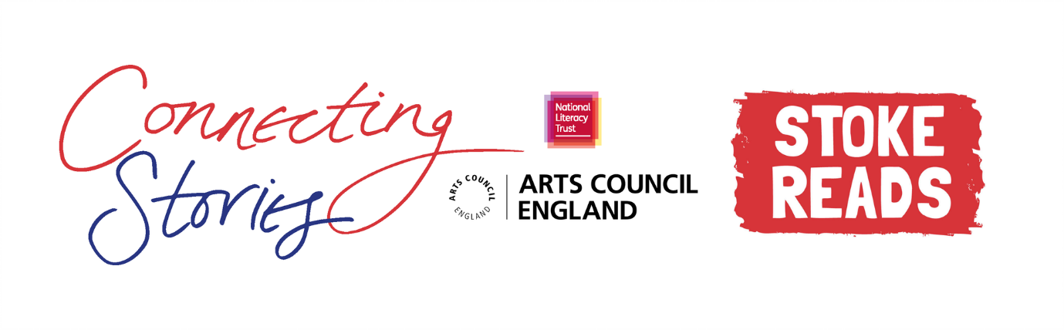

**Creative Writing Competition: ‘City of Kindness’**

**National Literacy Trust** and **Stoke Reads** are delighted to launch an exciting creative writing competition as part of the Connecting Stories project, with support from author Anna James. We are inviting children aged 7-11 from Stoke-on-Trent to create a piece of writing based on the theme ***‘City of Kindness’.***

Did you know that Stoke-on-Trent was voted as the UK’s kindest city for carrying out acts of kindness in 2020?* Tell us about an act of kindness you’ve witnessed happening around you - this could be a real life example or imagined.

You can choose any format you like – a story, a poem, news article or diary entry. You can include some illustrations too.

Everyone who enters the competition will receive a certificate and will have a chance to get their work published in an anthology and displayed in a local exhibition. There will also be book prizes for the winning entries.

Winning entries will be chosen based on originality, imagination, relation to the theme and overall enjoyment.

**How to enter**

* Use the blank space in this booklet or a side of A4 paper to complete your piece of writing.
* Ask your parent/guardian or teacher to scan or photograph your work and enter online at <https://literacytrust.org.uk/communities/stoke/connecting-stories/>
* Or you can email it to [stokecs@literacytrust.org.uk](mailto:stokecs@literacytrust.org.uk). Don’t forget to include your first name and first letter of your surname, your age and school.

**Privacy notice**

The National Literacy Trust will need to hold and process your personal data in order to manage this competition. We will only use it for this purpose we will never pass on personal information to any other organisations unless specific consent has been given. For our full privacy policy see [literacytrust.org.uk/privacy](https://literacytrust.org.uk/information/privacy-policy/).



**‘City of Kindness’: Writing prompts**

Your piece of writing can be funny, heart-warming, adventurous or exciting, fiction or non-fiction. Everything is welcome!

Here are some ideas to get you started.

* Can you tell us about the kindest person you know? Why do you think they are kind? What kind things have they done?
* Kindness can mean a lot of things: listening, baking cookies to share, forgiveness, making a thankyou card or calling a family member for a chat. What does it mean to you?
* Have you ever seen any random acts of kindness between strangers?
* How will you be kind in the future? This could be tomorrow, next year or in twenty years! What will you do?

1. **The Legend of Podkin One-Ear by Kieran Larwood**

My favourite book about talking animals, this is a fast-paced story about rabbits, legends and stories within stories that’s full of brilliant world-building and page-turning adventure.

1. **Me, My Dad and the End of the Rainbow by Benjamin Dean**

Another new book, this is such a joyful and uplifting story set in modern-day London, about a boy whose Dad comes out as gay and the impact that has on their relationship.

1. **Pippi Longstocking by Astrid Lindgren**

Another favourite of mine, and a story I’d love to bookwander inside. Pippi is one of my favourite characters (and another redhead like Anne – and me!). She’s brave and wild and I wish she was my best friend!

1. **Bloom by Nicola Skinner**

I love all of Nicola Skinner’s novels, but her first one, Bloom, is a great place to start (although be sure to check out her new book that’s coming out in April called Starboard!). This is a weird and wonderful story of being true to yourself.

1. **Front Desk by Kelly Yang**

If magic isn’t so much of your thing, try this funny and thought-provoking story inspired by the author’s real-life experiences and family. It’s about a Chinese family who move to the US and end up managing a motel, including daughter Mia who runs the front desk.

1. **Charmed Life by Diana Wynne Jones**

Diana Wynne Jones is my favourite author if I think about all her work, and this is a great place to start. It’s got magic and parallel worlds and a mysterious sorcerer, as well as being very funny. And if you like it, it’s the first in a series!

1. **Anne of Green Gables by LM Montgomery**

This was one of my favourite books as a child, and still is today, and it had a big impact on Pages & Co. Anne Shirley is one of the greatest fictional characters ever created, and even though this book was written a long time ago, it’s still a brilliantly fun and moving story to read today.

1. **Momo by Michael Ende**

This book isn’t known as well Ende’s more famous novel, The Neverending Story, but it’s my favourite. It’s a strange and exciting book about the power of stories, imagination and friendship, and the villains in it inspired Enoch Chalk, the baddy in Tilly and the Bookwanderers.

1. **Amari and the Night Brothers by BB Alston**

A new book that’s a bit like Men in Black meets Nevermoor. It’s the story of Amari, who follows her disappeared brother into the Bureau of Supernatural Affairs, and it’s a brilliant combination of fresh, high-tech magic and classic fantasy adventure.

1. **Dragon Mountain by Katie & Kevin Tsang**

A fast-paced, super imagination story of dragons and hidden legends set in China. A great read if you like your stories packed full of action, magic and mystery!

**Author Anna James Recommends… Top 10 books to help your writing!**

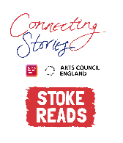First name and the first letter of your surname: Click here to enter text.

Age: Click here to enter text. School: Click here to enter text.

Parent/Guardian/Teacher email address: Click here to enter text.

Parent/Guardian: I give permission for this work, along with the name and school provided, to be published in an anthology and displayed online or in public venues.

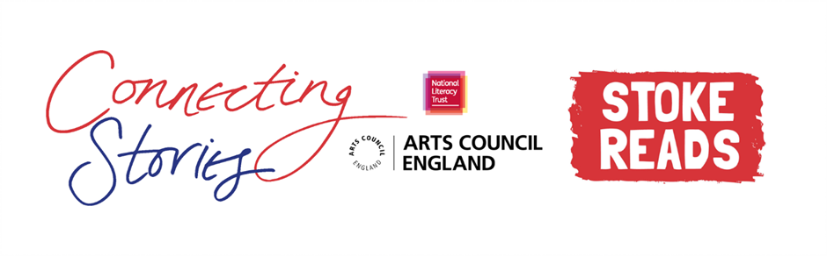

**Competition Rules**

* The competition is open to young people aged 7-11, but entries from all primary school pupils will be considered for the exhibition.
* The closing date for submission is Friday 12th March 2021. Winners will be announced at the beginning of April.
* Entries should be one page of A4 or 500 words maximum and written in English.
* The piece of creative writing must be an original piece of work and be wholly written by the entrant. It must reflect the theme of the competition as stated in the competition challenge. The writing must be single-authored.
* Entries must not contain obscene, defamatory, offensive or otherwise unsuitable material. The organisers reserve the right to disqualify such entries.
* A team of community partners and National Literacy Trust staff will shortlist entries and winners will be chosen by our panel of experts.
* On submission, parents/guardians will be asked to grant permission to enter. They will be asked for consent to publish the entrant’s writing online or in print form, or display physical entries in public spaces.
* Teachers submitting on behalf of their pupils must obtain permission from parents/ guardians prior to submission. As a teacher, by entering your pupils’ work into this competition you are confirming that written parental consent has been sought and confirmed in advance of the submission. National Literacy Trust will not be held liable in the instance that consent has not been sought.