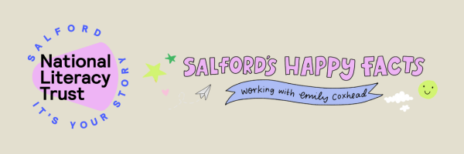
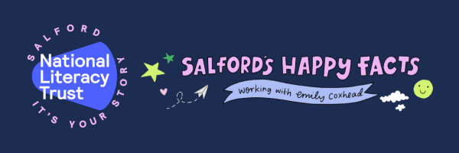
Did you know…?
When children read for pleasure, their confidence increases, as well as their ability to relax and better understand the world around them. The National Literacy Trust in Salford has launched a campaign to use children’s hobbies and interests as a springboard to discover reading for pleasure – because children’s natural curiosity about the world means they are more motivated to read when it’s about something that fascinates them.
Whether your child is interested in sharks, space, sewing, or something else entirely, our school is collecting Happy Facts from pupil’s local communities to share with the National Literacy Trust in Salford, some of which could be chosen to be included in a published collection later this year! You can help your child explore their interests by visit your local library, speaking to local experts in their chosen subject, or by talking a walk around your local neighbourhood to discover some interesting facts on your doorstep.
For more information about the campaign, upcoming events, and how you can get involved, follow the National Literacy Trust in Salford on Facebook at www.fb.com/SalfordLiteracyTrust

