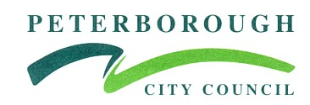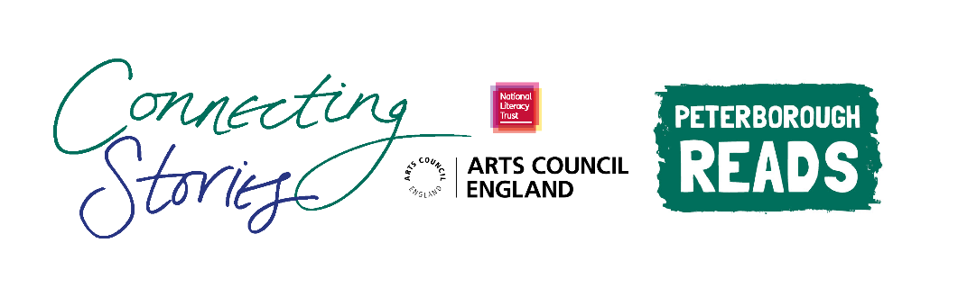

**Creative Writing Competition: ‘The World Around Us’**

**National Literacy Trust** and **Peterborough Reads** are delighted to launch an exciting creative writing competition as part of the Connecting Stories project, with support from author Danny Wallace. We are inviting children aged 7-11 from across Peterborough to create a piece of writing based on the theme ***‘The World Around Us’.***

We want you to write a piece of creative writing about a place that is special to you. This can be as simple as a description of a place you see on your journey to school, your favourite local park, football stadium, even your own street! You could get really creative and imagine something extraordinary taking place in your chosen location. Maybe the local shopping centre has been taken over by aliens, or Peterborough Cathedral has started levitating high above the city. It’s up to you!

You can choose any format you like – a story, a poem, news article or diary entry. You can include some illustrations too.

Everyone who enters the competition will receive a **certificate** and will have a chance to get their work published in an **anthology** and displayed in a local **exhibition**. There will also be book prizes for the winning entries.

Winning entries will be chosen based on originality, imagination, relation to the theme and overall enjoyment.

**How to enter**

* Use the blank space in this booklet or a side of A4 paper to complete your piece of writing.
* Ask your parent/guardian or teacher to scan or photograph your work and enter online at [www.literacytrust.org.uk/communities/connecting-stories](http://www.literacytrust.org.uk/communities/connecting-stories) or email it to peterboroughcs@literacytrust.org.uk. Don’t forget to include your first name and first letter of your surname, your age and school.

**Privacy notice**

The National Literacy Trust will need to hold and process your personal data in order to manage this competition. We will only use it for this purpose we will never pass on personal information to any other organisations unless specific consent has been given. For our full privacy policy see literacytrust.org.uk/privacy



**‘The World Around Us’: Writing prompts**

Your piece of writing can be funny, heart-warming, adventurous or exciting, fiction or non-fiction, everything is welcome!

Here are some ideas to inspire you if you’re feeling a bit stuck:

* Think about places that you know well, that you enjoy visiting and can easily picture and imagine.
* Use all of your senses. What does it look, smell, and sound like?
* What do you like to do at this place, and who with?
* What else lives there?
* Why is this place special to you?
* Maybe you arrive at your favourite place, but you suddenly notice that something strange is happening…
* Ask your friends and family about local places that they love, and use this as inspiration!
* You could write a diary entry talking about a trip to your chosen place, or a news article reporting on something crazy that is happening there!

**Writing tip from Danny Wallace:**

*“Everything is an idea, everything anyone says, anyone you see walking in the street, you can come up with something about them. It’s everywhere. You just have to think about the questions you would ask. Where’s he going? What’s she doing for a job?*

*What if he was a superhero?”*

First name and first letter of surname Click or tap here to enter text.

Age Click or tap here to enter text.

School Click or tap here to enter text.

Parent/Guardian/Teacher email address Click or tap here to enter text.

Parent/Guardian: I give permission for this work, along with the name, age and school provided, to be published in an anthology and displayed online or in public venues.



**Competition Guidance**

* The competition is open to children and young people aged 7-11, however, we can accept entries from all primary year groups for our exhibition.
* The closing date for submission is Friday 12th March 2021. Winners will be announced at the beginning of April.
* Entries should be one page of A4 or 500 words maximum and written in English.
* The piece of creative writing must be an original piece of work and be wholly written by the entrant. It must reflect the theme of the competition as stated in the competition challenge. The writing must be single-authored.
* Entries must not contain obscene, defamatory, offensive or otherwise unsuitable material. The organisers reserve the right to disqualify such entries.
* A team of community partners and National Literacy Trust staff will shortlist entries and winners will be chosen by our panel of experts.
* On submission, parents/guardians will be asked to grant permission to enter. They will be asked for consent to publish the entrant’s writing online or in print form, or display physical entries in public spaces.
* Teachers submitting on behalf of their pupils must obtain permission from parents/ guardians prior to submission. As a teacher, by entering your pupils’ work into this competition you are confirming that written parental consent has been sought and confirmed in advance of the submission. National Literacy Trust will not be held liable in the instance that consent has not been sought.