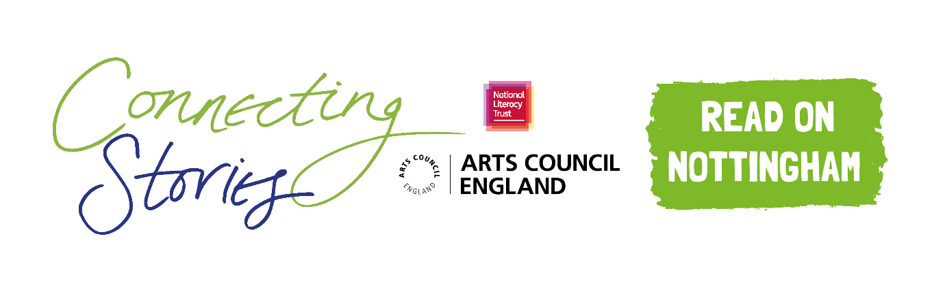

**Creative Writing Competition: ‘Friends, Family and Relationships’**

**National Literacy Trust** and **Read on Nottingham** are delighted to launch an exciting creative writing competition as part of the Connecting Stories project, with support from authors **Darren Simpson** and **L. D. Lapinski**. We are inviting children aged 7-11 from across Nottingham to create a piece of writing based on the theme ***‘Friends, Family and Relationships’.***

We want you to write a piece of creative writing about your friends, family or other people that are important to you. This could be a description of what makes them special, the story of the first time you met, something you like to do together. You could even create a short fictional story based on the people in your life. Maybe you give them special powers? Go on a crazy journey somewhere together? It’s up to you!

You can choose any format you like – a story, a poem, news article or diary entry. You can include some illustrations too.

Everyone who enters the competition will receive a certificate and will have a chance to get their work published in an anthology and displayed in a local exhibition. There will also be book prizes for the winning entries.

Winning entries will be chosen based on originality, imagination, relation to the theme and overall enjoyment.

**How to enter**

* Use the blank space in this booklet or a side of A4 paper to complete your piece of writing.
* Ask your parent/guardian or teacher to scan or photograph your work and enter online at [www.literacytrust.org.uk/communities/connecting-stories](http://www.literacytrust.org.uk/communities/connecting-stories) or email it to nottinghamcs.primary@literacytrust.org.uk. Don’t forget to include your first name and first letter of your surname, your age and school.

**Privacy notice**

The National Literacy Trust will need to hold and process your personal data in order to manage this competition. We will only use it for this purpose we will never pass on personal information to any other organisations unless specific consent has been given. For our full privacy policy see literacytrust.org.uk/privacy



**‘Friends, Family and Relationships’: Writing prompts**

Your piece of writing can be funny, heart-warming, adventurous or exciting, fiction or non-fiction, everything is welcome!

Here are some ideas to inspire you if you’re feeling a bit stuck:

* Think about your friends and family, and write down what you love about them. Is it how they make you laugh? Do they help you to achieve difficult things?
* What kinds of things do you enjoy doing together? Can you describe a typical day with them?
* Your writing could even take the form of a letter you write to an older relative, telling them why they are important to you.

**Fantasy option: ‘People and Places: Travelling to Imaginary Worlds’**

Alternatively, you could take up L. D. Lapinski’s challenge and write about a trip you take to a fantasy world with the people in your life, inspired by the main character Flick’s adventures in L. D’s *The Strangeworlds Travel Agency.*

* Where are you trying to get to? What obstacles do you face along the way? Maybe you and your friends have special powers to help you along the way!
* What is your world like? What is weird and wonderful about it? How do you get there?

First name and first letter of surname Click or tap here to enter text.

Age Click or tap here to enter text.

School Click or tap here to enter text.

Parent/Guardian/Teacher email address Click or tap here to enter text.

Click or tap here to enter text.

Parent/Guardian: I give permission for this work, along with the name, age and school provided, to be published in an anthology and displayed online or in public venues.



**Competition Guidance**

* The competition is open to children and young people aged 7-11, but entries from all primary school pupils will be considered for the exhibition.
* The closing date for submission is Friday 12th March 2021. Winners will be announced at the beginning of April.
* Entries should be one page of A4 or 500 words maximum and written in English.
* The piece of creative writing must be an original piece of work and be wholly written by the entrant. It must reflect the theme of the competition as stated in the competition challenge. The writing must be single-authored.
* Entries must not contain obscene, defamatory, offensive or otherwise unsuitable material. The organisers reserve the right to disqualify such entries.
* A team of community partners and National Literacy Trust staff will shortlist entries and winners will be chosen by our panel of experts.
* On submission, parents/guardians will be asked to grant permission to enter. They will be asked for consent to publish the entrant’s writing online or in print form, or display physical entries in public spaces.
* Teachers submitting on behalf of their pupils must obtain permission from parents/ guardians prior to submission. As a teacher, by entering your pupils’ work into this competition you are confirming that written parental consent has been sought and confirmed in advance of the submission. National Literacy Trust will not be held liable in the instance that consent has not been sought.