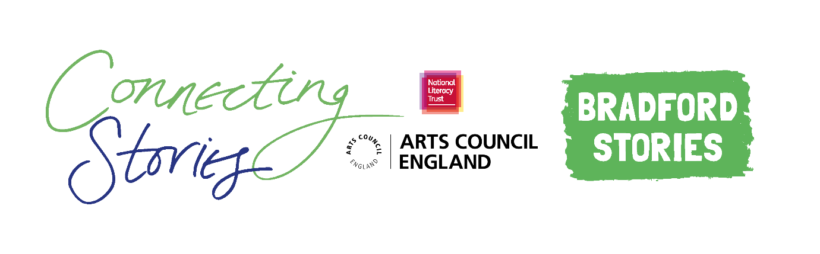
Creative Writing Competition: ‘Connections’
National Literacy Trust and Bradford Stories are delighted to launch an exciting creative writing competition as part of the Connecting Stories project, with support from the fantastic Bradford author Sairish Hussain. We are inviting young people aged 11-14 to create a piece of writing based on the theme ‘Connections’
We want you to write a piece of creative writing that explores a connection you have to a place, friend, family member, someone in your community or to your local or family heritage. You could also write about anything else you feel a connection to! For example, a fictional character, a celebrity or a historical figure!

You can choose any format you like – a story, a poem, news article or diary entry. You can include some illustrations too.
Everyone who enters the competition will receive a certificate and will have a chance to get their work published in an anthology and displayed in a local exhibition. There will also be book prizes for the winning entries.
Winning entries will be chosen based on originality, imagination, relation to the theme and overall enjoyment.
How to enter
- Use the blank space in this booklet or a side of A4 paper to complete your piece of writing.
- Ask your parent/guardian or teacher to scan or photograph your work and enter online at www.literacytrust.org.uk/communities/connecting-stories or email it to bradfordcs.secondary@literacytrust.org.uk. Don’t forget to include your first name and first letter of your surname, your age and school.

Privacy notice
The National Literacy Trust will need to hold and process your personal data in order to manage this competition. We will only use it for this purpose we will never pass on personal information to any other organisations unless specific consent has been given. For our full privacy policy see literacytrust.org.uk/privacy
‘Connections’: Writing prompts
Your piece of writing can be funny, heart-warming, adventurous or exciting, fiction or non-fiction, everything is welcome!
Here are some ideas to inspire you if you’re feeling a bit stuck:
- Think about all the people who are important to you. What is it about them that makes them special?

- You could write a letter to an older relative, telling them why they are important to you.

- You could think about your favourite books, games, movies and TV shows. Maybe you feel a connection with the people, characters or the places in them that you would like to write about.

- Think about a local place that you have a connection to. What does it look, smell and sound like? What makes it special? Why do you enjoy visiting this place?

- You could write a newspaper article describing what you love about Bradford.

- You could talk to family members about the connections they feel to their family heritage, and write about what you learn.

- Think about any new connections have you made over the last year. Maybe you could write about someone who has helped you with something difficult?

First name and first letter of surname Click or tap here to enter text.
Age Click or tap here to enter text.
School Click or tap here to enter text.
Parent/Guardian/Teacher email address Click or tap here to enter text.

☐ Parent/Guardian: I give permission for this work, along with the name, age and school provided, to be published in an anthology and displayed online or in public venues.
Competition Guidance

- The competition is open to children and young people aged 11-14, but entries from all secondary school pupils will be considered for the exhibition.

- The closing date for submission is Friday 12th March 2021. Winners will be announced at the beginning of April.

- Entries should be one page of A4 or 500 words maximum and written in English.

- The piece of creative writing must be an original piece of work and be wholly written by the entrant. It must reflect the theme of the competition as stated in the competition challenge. The writing must be single-authored.

- Entries must not contain obscene, defamatory, offensive or otherwise unsuitable material. The organisers reserve the right to disqualify such entries.

- A team of community partners and National Literacy Trust staff will shortlist entries and winners will be chosen by our panel of experts.

- On submission, parents/guardians will be asked to grant permission to enter. They will be asked for consent to publish the entrant’s writing online or in print form, or display physical entries in public spaces.

- Teachers submitting on behalf of their pupils must obtain permission from parents/ guardians prior to submission. As a teacher, by entering your pupils’ work into this competition you are confirming that written parental consent has been sought and confirmed in advance of the submission. National Literacy Trust will not be held liable in the instance that consent has not been sought.

