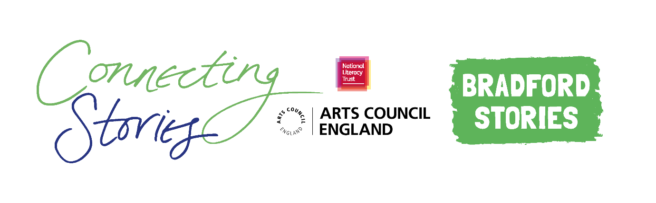
Creative Writing Competition: ‘Our Journeys’
Connecting Stories Black Country are delighted to launch an exciting creative writing competition, with support from authors A. M. Dassu and Benjamin Dean. We are inviting children aged 7-11 from across the Black Country to create a piece of writing based on the theme ‘Our Journeys’
We invite children and young people to write a piece of creative writing about a real or imagined journey. This can be a journey you know well, like your trip to school, the supermarket, or your local park. But a journey can also be as magical as a trip to the future, or as exciting as moving to a new neighbourhood or country. Whatever it is, we want to read about your journeys!

You can choose any format you like – a story, a poem, news article or diary entry. You can include some illustrations too.
Everyone who enters the competition will receive a certificate and will have a chance to get their work published in an anthology and displayed in a local exhibition. There will also be book prizes for the winning entries.
Winning entries will be chosen based on originality, imagination, relation to the theme and overall enjoyment.
How to enter
- Use the blank space in this booklet or a side of A4 paper to complete your piece of writing.
- Ask your parent/guardian or teacher to scan or photograph your work and enter online at www.literacytrust.org.uk/communities/connecting-stories or email it to blackcountrycs@literacytrust.org.uk. Don’t forget to include your first name and first letter of your surname, your age and school.
Privacy notice
The National Literacy Trust will need to hold and process your personal data in order to manage this competition. We will only use it for this purpose we will never pass on personal information to any other organisations unless specific consent has been given. For our full privacy policy see literacytrust.org.uk/privacy
‘Our Journeys’: Writing prompts
Your piece of writing can be funny, heart-warming, adventurous or exciting, fiction or non-fiction, everything is welcome! In A. M. Dassu’s wonderful book Boy, Everywhere, she writes about her main character’s journey across countries and continents, but a journey can take many different forms.
Here are some ideas to inspire you if you’re feeling a bit stuck:
- Think about a journey that you take regularly. It could be your trip to school, to a friend’s house, to the shops. Try and picture the things that you see, hear and smell along the way. You could even make these things up completely!

- When you are on the journey, how do you feel? Are you excited? Scared? Happy?

- You could try to imagine something unexpected, strange or magical happening on this journey. Maybe the bus you’re in starts to float, or an angry bear is blocking the street. Maybe everyone around you starts to dance for no reason. What would make you laugh?

- You could also ask your family members about a journey that they have taken in their life, and write about what you learn from them.

- You could write a diary entry describing your journey and what happens, or even a news article reporting on your real or imagined journey.

Name and first letter of surname Click or tap here to enter text.
Age Click or tap here to enter text.
School Click or tap here to enter text.
Parent/Guardian/Teacher email address Click or tap here to enter text.
Click or tap here to enter text.

☐ Parent/Guardian: I give permission for this work, along with the name, age and school provided, to be published in an anthology and displayed online or in public venues.
Competition Guidance

- The competition is open to children and young people aged 7-11, but entries from all primary school pupils will be considered for the exhibition.

- The closing date for submission is Friday 12th March 2021. Winners will be announced at the beginning of April.

- Entries should be one page of A4 or 500 words maximum and written in English.

- The piece of creative writing must be an original piece of work and be wholly written by the entrant. It must reflect the theme of the competition as stated in the competition challenge. The writing must be single-authored.

- Entries must not contain obscene, defamatory, offensive or otherwise unsuitable material. The organisers reserve the right to disqualify such entries.

- A team of community partners and National Literacy Trust staff will shortlist entries and winners will be chosen by our panel of experts.

- On submission, parents/guardians will be asked to grant permission to enter. They will be asked for consent to publish the entrant’s writing online or in print form, or display physical entries in public spaces.

- Teachers submitting on behalf of their pupils must obtain permission from parents/ guardians prior to submission. As a teacher, by entering your pupils’ work into this competition you are confirming that written parental consent has been sought and confirmed in advance of the submission. National Literacy Trust will not be held liable in the instance that consent has not been sought.

